**Salesforce-CRM**

The Rice Mill CRM Application optimizes daily workflows in a wholesale rice mill through Salesforce. It incorporates comprehensive reporting, roll-up summary fields, cross-object formulas, validation rules, and permission sets. This project improves operational efficiency and enhances customer experience.

**PROJECT NAME: A CRM Application for Wholesale Rice Mill**

A Salesforce-powered CRM application designed to optimize operations in a wholesale rice mill. This solution enhances workflow efficiency, streamlines processes, and improves overall operational management.

**Prepared by**: A.BHAVANA

**Mail Id**: 21bk1a0501@stpetershyd.com

**College Name**: St. Peter's Engineering College

**INDEX**

● Abstract

● Introduction

● Project Objectives

● Description

● Project Overview

● Prerequisites

■ Salesforce Developer Account

■ Basic Knowledge of Salesforce Admin Concepts

■ Web Browsers

■ Good Internet Connectivity

● Features and Functionality

■ Reporting and Dashboards

■ Rollup Summary Fields

■ Cross-Object Formula Fields

■ Validation Rules

■ Permission Sets

● Milestones and Activities

■ Creating Developer Account

■ Creating Objects

■ Creating Tabs

■ Creating Lightning App

■ Creating Fields

■ Creating Page Layouts

■ Creating Profiles, Roles, and Role Hierarchy

■ Creating Users

■ Creating Permission Sets

■ Creating Reports

■ Creating Dashboards

● Apex Development

■ Apex Class (ConsumerRecord)

■ Apex Trigger

● What I Gained from the Project

● Future Enhancements

● Conclusion

● References

**Abstract**

This report outlines the creation of an advanced Customer Relationship Management (CRM) application tailored to enhance the daily operations of a wholesale rice mill. Built on the Salesforce platform, the application leverages its powerful, flexible, and scalable features to streamline workflows and strengthen customer relationships. The primary objective of this CRM solution is to optimize the rice mill’s operational processes, including production, sales, inventory management, and customer engagement, thereby boosting efficiency and resource utilization.

Key highlights of the application include:

* **Advanced Reporting Tools:** Deliver detailed insights into sales trends, revenue generation, customer preferences, and other crucial metrics, enabling data-driven decisions.
* **Roll-up Summary Fields:** Provide consolidated views of business activities by aggregating data from related records, such as total rice quantities supplied or sold by specific suppliers or customers.
* **Cross-object Formula Fields:** Enable precise and automated calculations across related objects, ensuring accuracy in financial data, such as payments calculated based on rice quantities and pricing.
* **Validation Rules:** Enforce data integrity by preventing errors and ensuring only valid entries in critical areas like production records, sales transactions, and customer information.
* **Permission Sets:** Control user access by defining data visibility and editing rights, safeguarding sensitive information and maintaining operational security.

By integrating these features, the CRM application significantly enhances the efficiency of the rice mill’s operations. It supports real-time analytics for better decision-making, provides a unified view of inventory and sales for improved resource management, and fosters a superior customer experience through timely and personalized services.

This application empowers the rice mill to operate more effectively, reduce costs, and improve customer satisfaction. It also lays a strong foundation for future enhancements and scalability, ensuring the sustainability and growth of the business. The successful implementation of this CRM application positions it as a transformative tool for the wholesale rice mill, driving improved workflows and business performance.

**Introduction**

The wholesale rice milling industry forms a cornerstone of the global food supply chain, producing a vital commodity that supports diverse sectors, including agriculture, retail, and food processing. Despite its critical role, this industry grapples with numerous operational challenges. The complexity of managing rice production, inventory, customer relationships, and sales, coupled with the need for precise reporting and effective communication between stakeholders, often results in inefficiencies. These inefficiencies can lead to suboptimal resource allocation, errors in data management, and missed opportunities for improving customer satisfaction.

The intricate demands of rice milling operations, such as monitoring production levels, tracking inventory, managing supplier and customer interactions, and ensuring timely distribution, require an organized and reliable system. Traditional methods, which rely heavily on manual processes or fragmented systems, often fall short in addressing these needs, leading to gaps in operational efficiency and decision-making.

In this context, implementing a robust Customer Relationship Management (CRM) system tailored to the rice milling industry can address these challenges effectively. A CRM system centralizes operational data, streamlines workflows, and provides actionable insights, enabling rice mills to operate more efficiently. Salesforce, renowned for its flexibility, scalability, and feature-rich ecosystem, is an ideal platform for building such a system. By leveraging Salesforce’s capabilities, this project aims to develop a CRM application specifically designed to address the unique operational needs of the rice milling industry.

**Project Objectives**

The CRM application aims to achieve the following key objectives:

1. **Design an Intuitive and User-Friendly Application:** Simplify user interaction by creating a seamless interface that can be easily navigated by users with minimal training.
2. **Streamline Operations and Reporting:** Automate complex workflows, reduce manual errors, and enhance the efficiency of daily tasks such as production tracking, sales management, and inventory control.
3. **Enhance Customer Experience:** Centralize customer data to deliver personalized services and improve response times, ultimately fostering stronger customer relationships.
4. **Ensure Data Security and Integrity:** Implement robust security measures, including validation rules and permission sets, to protect sensitive business information.

**Description**

The application is built on the Salesforce platform and incorporates the following core architectural components and features:

* **Custom Objects:**  
  The application utilizes custom objects to represent key entities such as Suppliers, Rice Mills, Consumers, and Rice Details. These objects are structured to reflect the relationships and interactions among these entities.
* **Data Fields:**  
  Various field types, including roll-up summary fields and cross-object formula fields, are implemented to support dynamic data aggregation and real-time calculations. For example, roll-up summary fields enable users to view total sales or inventory at a glance, while formula fields automate calculations such as payment amounts based on rice quantities and pricing.
* **Relationships:**  
  Master-detail relationships are established to create a hierarchical structure that ensures data consistency and simplifies reporting. For instance, a master-detail relationship between Rice Mills and Suppliers provides a consolidated view of supplier contributions.
* **User Interface:**  
  The application includes custom tabs, page layouts, and a Lightning app that provides a modern, streamlined navigation experience. This ensures that users can access key functionalities with ease, improving adoption and usability.
* **Security Measures:**  
  To safeguard sensitive data, validation rules are implemented to enforce data integrity by restricting invalid or incomplete entries. Permission sets control user access based on roles, ensuring that only authorized personnel can view or modify specific data.

**Project Overview**

The Rice Mill CRM Application is a robust and comprehensive solution tailored to simplify and optimize the daily operations of a rice mill. Designed for owners, managers, and team members alike, this application is a valuable tool that makes managing everyday tasks more efficient and organized.

At its core, the Rice Mill CRM Application addresses the complexities of running a rice mill by focusing on streamlining critical processes, including tracking rice production, managing sales, and fostering customer relationships. It provides a centralized platform to oversee these operations, ensuring that all aspects are handled effectively and efficiently.

The application empowers businesses to save time, reduce errors, and enhance overall performance by automating routine tasks and offering actionable insights. Whether it's real-time monitoring of sales, efficient resource allocation, or maintaining strong customer connections, the Rice Mill CRM Application is designed to meet the unique demands of the rice milling industry while driving improved productivity and operational success.

**Why This Application Matters**

Managing a rice mill involves juggling numerous responsibilities, from monitoring inventory levels to tracking production and maintaining strong relationships with customers and suppliers. Without a centralized system, these tasks can become overwhelming, leading to inefficiencies, errors, and missed opportunities for growth.

The Rice Mill CRM Application addresses these pain points by acting as a centralized hub for all operational data. It ensures that critical information is easily accessible, reduces the time spent on manual tracking, and enables better communication across the organization. This, in turn, allows rice mill operators to focus on strategic priorities such as business expansion and customer satisfaction.

**Key Features**

1. **Daily Sales Tracking**  
   The Rice Mill CRM Application provides real-time tracking of rice sales, allowing users to instantly access daily sales data. It identifies popular rice varieties and calculates total revenue generated, enabling rice mill operators to make quick, informed adjustments to optimize profitability and sales strategies.
2. **Customer Management**  
   A centralized database stores detailed customer information, including purchase history, preferences, and communications. This focus on personalization enhances customer service, builds loyalty, and ensures lasting relationships, helping operators maintain strong and efficient customer connections.
3. **Easy Reporting**  
   The application simplifies the creation of detailed reports for metrics such as sales, revenue, and inventory levels. With user-friendly, actionable insights, these reports enable managers and owners to analyze performance and plan effectively for business growth.
4. **User-Friendly Design**  
   Designed with simplicity in mind, the application features an intuitive interface suitable for users with varying technical expertise. Minimal training is required, ensuring high adoption rates and a seamless user experience right from the start.

### Benefits for Your Business

By leveraging the Rice Mill CRM Application, rice mill operators can:

* **Save Time and Reduce Errors:** Automation reduces the need for manual data entry, minimizing stress and the likelihood of errors.
* **Focus on Core Activities:** Centralized data management ensures no critical details are missed, allowing users to concentrate on growing their business and improving efficiency.
* **Adapt to Business Growth:** The application is scalable and customizable, enabling businesses to add new features, expand functionalities, or integrate with other tools and systems as needed.
* **Enhance Strategic Decision-Making:** With insightful analytics and comprehensive reports, operators can make better-informed decisions to achieve strategic goals.

### Long-Term Impact

The Rice Mill CRM Application supports sustainable growth by:

* Enhancing operational efficiency and customer satisfaction.
* Offering flexibility and scalability to meet evolving business needs.
* Contributing significantly to the long-term success of rice mill operations.

### Prerequisites

Before starting with the Rice Mill CRM Application, ensure you have the following essentials to ensure a smooth setup and usage:

#### 1. Salesforce Developer Account

* **What It Is:** To build and customize the CRM application, a Salesforce Developer Account provides access to necessary tools and resources for application creation and modification.
* **How to Get It:** You can sign up for a free Salesforce Developer Edition account [here](https://developer.salesforce.com/signup). The signup process is quick and easy!

#### 2. Basic Knowledge of Salesforce Admin Concepts

* **Why It Matters:** Familiarity with Salesforce administration concepts is essential to successfully building and customizing the CRM application. It involves understanding objects, fields, relationships, and permissions.
* **What to Brush Up On:**
  + Creating and managing custom objects and fields
  + Designing page layouts and record types
  + Setting up permission sets and roles for user access control
  + Using validation rules and formula fields for data integrity

#### 3. Web Browsers

* **What You Need:** Ensure you have at least two web browsers installed on your machine for accessing Salesforce and testing the application.
* **Recommended Browsers:** Google Chrome, Mozilla Firefox, or Microsoft Edge will work best for a smooth experience.

#### 4. Good Internet Connectivity

* **Why It’s Important:** A reliable internet connection is crucial for using Salesforce efficiently and ensuring smooth operation of the CRM application.
* **Ideal Connectivity:** Aim for an internet speed of at least 5 Mbps to avoid any interruptions while working on the application.

#### 5. Basic Understanding of CRM Systems

* **What It Helps With:** Having a general idea of CRM systems will allow you to understand and make the most out of the CRM application’s features.
* **Topics to Know:**
  + The basics of CRM systems and their role in managing customer relationships
  + Common features and benefits of CRM tools, such as contact management, sales tracking, and reporting

#### 6. Familiarity with Reporting and Dashboards

* **Why It’s Useful:** Understanding how to create and interpret reports and dashboards is essential to gain insights from the application’s data.
* **What to Review:**
  + Creating and customizing reports to track sales, inventory, and customer metrics
  + Setting up and managing dashboards for quick access to key performance indicators (KPIs)

#### 7. Knowledge of Business Processes in a Rice Mill

* **Why It Helps:** Having a clear understanding of rice mill operations allows the CRM application to be more tailored to the unique needs of the industry.
* **Key Areas:**
  + Rice procurement and processing workflows
  + Sales and distribution management
  + Customer relationship management and maintaining supplier interactions

### Features and Functionality of the Rice Mill CRM Application

#### 1. Reporting and Dashboards

* **Purpose:** To provide actionable insights and a comprehensive view of operations.
* **Key Analytics:**
  + **Daily Rice Sales:** Track quantities and varieties sold daily.
  + **Total Income and Revenue Generated:** Monitor overall financial performance.
  + **Popular Amenities:** Identify the most sought-after features or services.
  + **Customer Buying Patterns:** Understand trends to enhance customer satisfaction and sales strategies.
* **Benefits:** These reports and dashboards empower the owner to:
  + Analyze performance trends
  + Optimize resource allocation
  + Strategically plan for future growth

#### 2. Rollup Summary Fields

* **What They Do:** Aggregate data from child objects to parent objects in master-detail relationships.
* **Key Functions:**
  + **COUNT:** Total number of related child records.
  + **SUM:** Aggregate numerical data from related records.
  + **MIN:** Lowest value in the child records.
  + **MAX:** Highest value in the child records.
* **Example:** Displaying the total value of rice supplied from individual rice details on a related supplier record.

#### 3. Cross-Object Formula Fields

* **Purpose:** Reference fields from one Salesforce object to another for dynamic calculations.
* **Example Use Case:** Calculating the total amount payable with the formula:
* **Benefits:** Automates calculations, reduces manual errors, and improves accuracy in financial and inventory tracking.

#### 4. Validation Rules

* **Purpose:** Ensure data integrity by preventing invalid entries.
* **How It Works:** Provide error messages when data does not meet specified criteria.
* **Example Rule:** Using the ISBLANK() function to validate whether a required field is empty. If it is, an error message prompts the user to complete the field.
* **Benefits:** Minimizes data errors and ensures consistent and reliable records.

#### 5. Permission Sets

* **Purpose:** Implement role-based access controls to secure data and manage user access.
* **Key Features:**
  + **Organization-Wide Defaults (OWD):** Define baseline access restrictions for all users.
  + **Role-Based Access:**
    - **Owner:** Full access to employer and worker records.
    - **Employer:** Limited access to worker records only.
* **Benefits:** Enhances data security and ensures each user only accesses the information relevant to their role.

**Milestones and Activities**

**1. Creating Developer Account**

Sign up for a Salesforce Developer account.

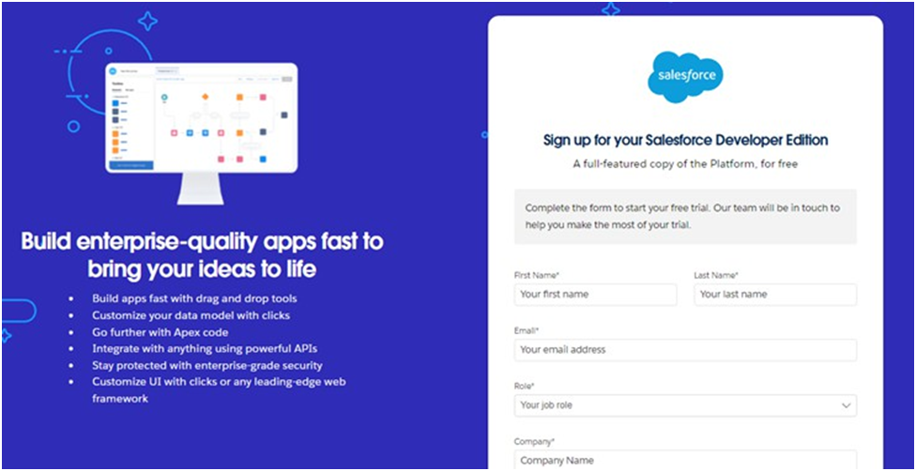**2.Creating Objects**

* 1. Supplier Object:Manage supplier details.

|  |  |
| --- | --- |
|  |  |
|  |  |

* 1. Rice Mill Object: Manage rice mill details.
  2. Consume rObject:Manage consumer details.
  3. RiceDetails Object:Track rice production and sales.

## 3.Creating Tabs

Create custom tabs for each object to easily access data.

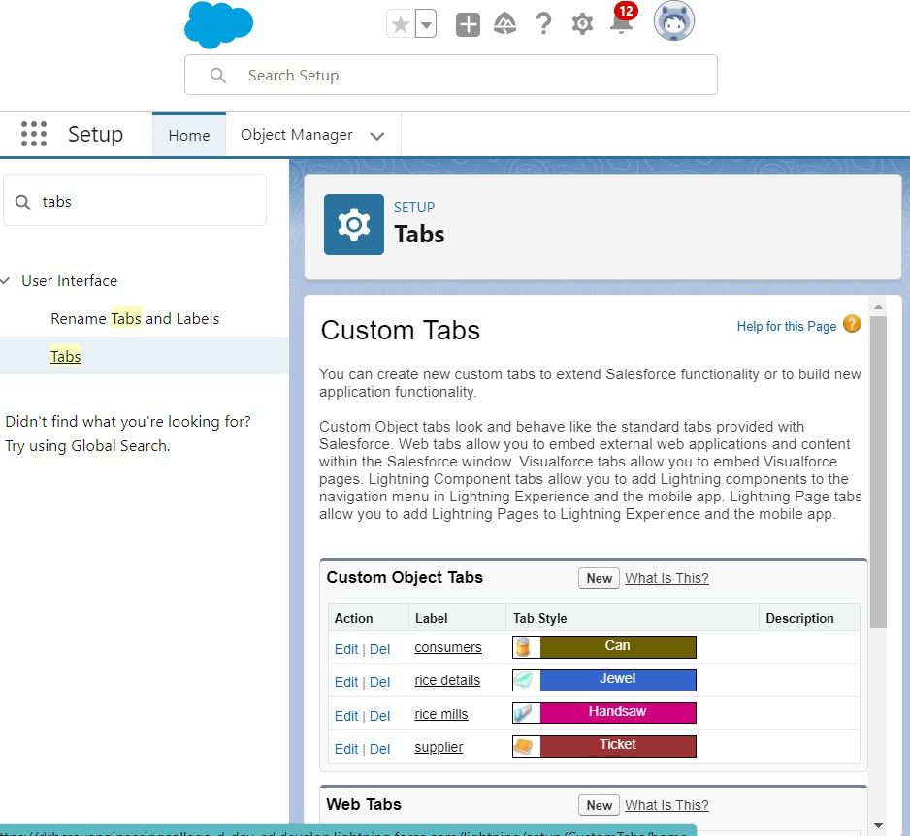

## 4.Creating Lightning App

Steps to create a Lightning app for the CRM application.

**5.Creating Fields*.***

* + **Number Field in Rice Details Object** : Tracksthequantityofrice.
  + **Junction Object**: Establishes relationships between the Rice Mill and other objects.
  + **Master-Detail Relationship** : Links objects such as Consumers and Rice Details.
  + **Roll-Up Summary** : Aggregates rice quantities from related records.
  + **Cross-Object Formula Field**: Calculates payments in Consumer records.
  + **Validation Rule** : Ensures that required fields are not left blank.

**6 .Creating Page Layouts**

Customize page layouts for each object to enhance user experience.

|  |  |
| --- | --- |
|  |  |
|  |  |

**7. Creating Profiles,Roles,and RoleHierarchy**

Define profiles to control user permissions. Create roles and set up a role hierarchy to establish data access levels.

1. **Owner Profile** : Full access to all data and functionalities.
2. **Employer Profile**: Access to Worker data and limited access toother records.
3. **Worker Profile** : Restricted access ,primarily to their own data.

**8 . Creating Users**

Add users to the Salesforce organization and assign appropriate profiles

and roles.

**9 . Creating Permission Sets**

Define permission sets to grant additional permissions to users beyond their profiles.

**10 . Creating Reports**

Create detailed reports to track rice production,sales,and other key metrics.

**11 . Creating Dashboards**

Design dashboards to provide visual summaries of key metrics and reports.

|  |  |
| --- | --- |
|  |  |
|  |  |

**Apex Development**

1. **Apex Class (ConsumerRecord) :** Manages operations related to Consumer records.

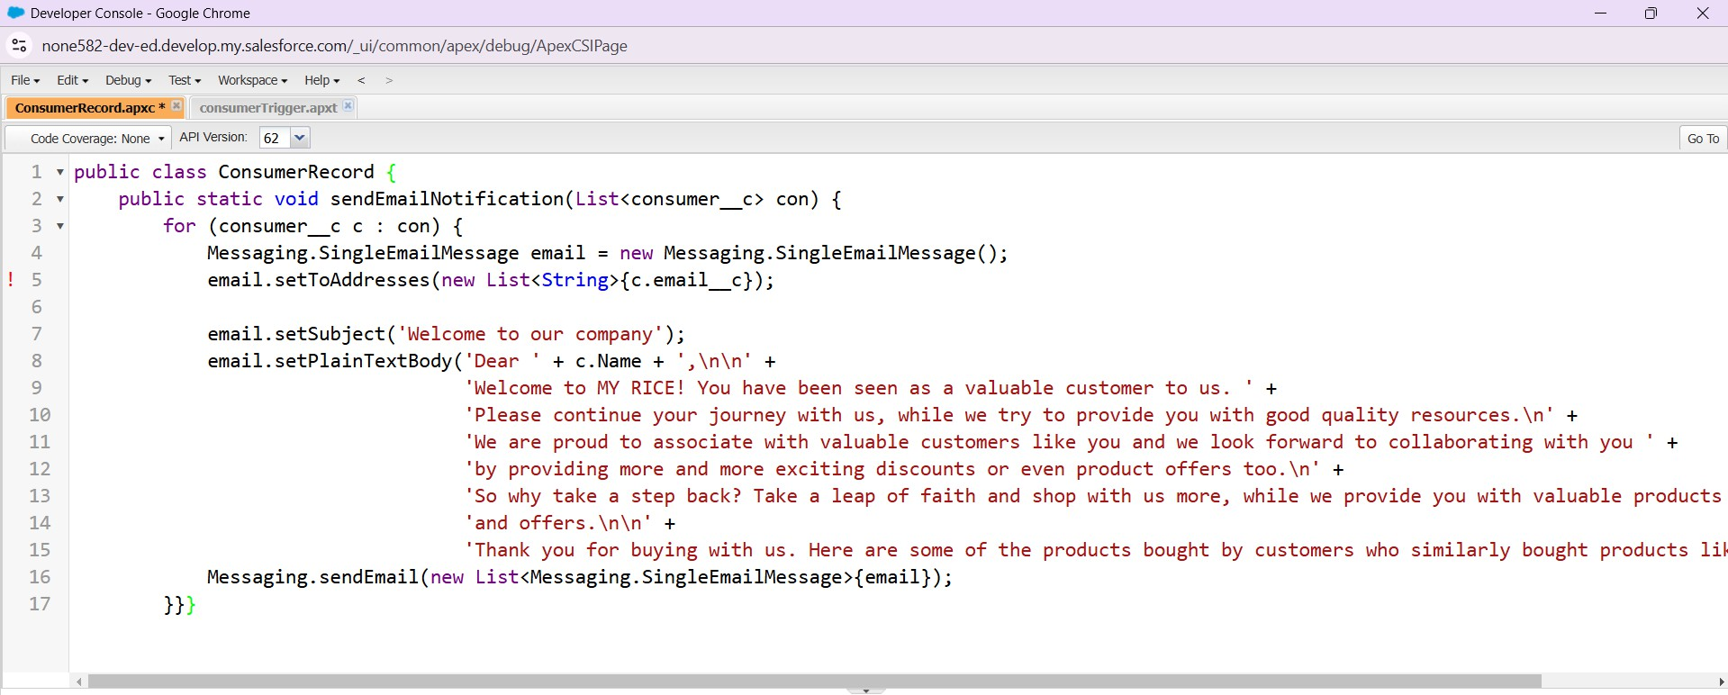

1. **Apex Trigger :** Automates specific processes, such as updating related records when a Consumer record is modified.

|  |  |
| --- | --- |
|  |  |
|  |  |

# **What I Gained from the Project**

Building the Rice Mill CRM Application hasbeenanincrediblejourney,and here’s a summary of what I’ve accomplished and learned through this project:

**1. Hands-On Salesforce Experience**

* **Learned Salesforce Configuration and Customization:**
  + Built a functional CRM system tailored to rice mill operations.
  + Set up components like objects, fields, and relationships to meet specific business needs.

#### 2. Understanding Objects & Relationships

* Gained in-depth knowledge of Salesforce objects and their interrelationships.
* Created and managed custom objects (e.g., Suppliers, Rice Mills, Consumers, and Rice Details) to construct an effective CRM system.

#### 3. Developing Formula Fields and Validation Rules

* **Formula Fields:**
  + Created fields for critical calculations, such as total payments based on rice quantity and price.
* **Validation Rules:**
  + Ensured data accuracy by restricting invalid or incomplete record entries.

#### 4. Applying Cross-Object Formula Fields

* Linked data across multiple Salesforce objects using cross-object formula fields.
* Enabled aggregated data views, like the total rice purchased by a consumer.

#### 5. Designing Page Layouts

* Customized page layouts for optimal usability:
  + Simplified access to data, such as rice purchase and supplier details.
  + Enhanced user navigation by organizing fields and sections effectively.

#### 6. Using Roll-Up Summary Fields

* Implemented roll-up summary fields to aggregate data from child records to parent records.
* Simplified inventory tracking with total rice quantities displayed for each supplier.

#### 7. Creating Reports and Dashboards

* Designed detailed reports and dashboards to visualize:
  + Daily rice sales
  + Total income and revenue
  + Popular rice varieties
* Enabled at-a-glance metrics for better decision-making and strategic planning.

### Future Enhancements

#### 1. Advanced Reporting Capabilities

* Add **custom report filters** for more granular insights.
* Enable **scheduled email updates** for automatic report delivery.
* Introduce **interactive dashboards** for real-time data exploration.

#### 2. Integration with External Systems

* Link the CRM with:
  + **Accounting software** to streamline financial tracking.
  + **Inventory tools** to maintain synchronized stock records.

#### 3. Enhanced User Interface and Experience

* Optimize the interface by:
  + Making it more intuitive with better navigation.
  + Adding **customizable dashboard widgets**.
  + Enhancing mobile responsiveness for on-the-go accessibility.

#### 4. Automated Workflows and Notifications

* Automate tasks like:
  + **Payment reminders** for due invoices.
  + **Inventory restocking alerts** when supplies run low.
* Increase efficiency and reduce manual oversight.

#### 5. Integration of AI and Analytics

* Leverage AI-driven tools to:
  + Predict sales trends and customer behavior.
  + Identify potential operational bottlenecks.
  + Provide actionable insights for staying competitive.

#### 6. Expanded User Training and Support

* Develop:
  + **Comprehensive user guides** and **video tutorials**.
  + An **online helpdesk** for troubleshooting and support.

### Conclusion

The Rice Mill CRM Application successfully streamlines daily operations, improving efficiency, resource management, and customer satisfaction. By automating key processes like sales tracking, customer management, and reporting, it reduces manual workload and minimizes errors. The application serves as a valuable tool for better decision-making and business growth. Future enhancements, such as integration with external systems and AI-driven analytics, promise to broaden its functionality and impact, ensuring its scalability and adaptability to evolving business needs.

### References

* **Salesforce Documentation**: Comprehensive guidance on Salesforce features and functionalities.
* **Community Forums**: Collaborative platforms for resolving technical challenges and exploring innovative solutions.